TI 22 – 56. Technology Example – Sulzer Chemtech’s Advanced VEICTM Oil-Water Seperation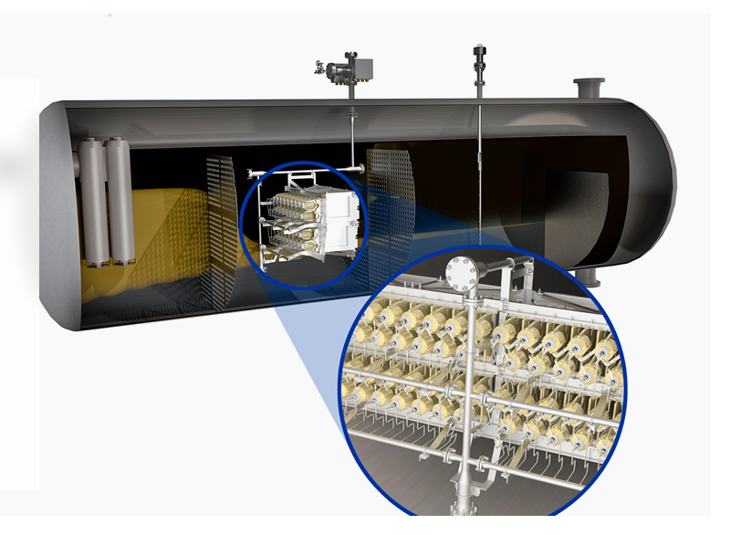

Sulzer Chemtech’s advanced VIEC™ boosts oil-water separation
By delivering top performance in liquid-liquid three-phase separation, Sulzer’s electrostatic coalescer internals for vessels VIEC™ is the ideal processing technology for oil and gas upstream operations. The solution can maximize productivity and separation efficiency, even in the most challenging oilfields.

While global oil demand remains solid, a growing number of oilfields are reaching maturity, i.e. they are characterized by higher volumes of free and emulsified water in oil emulsions. As a result, the effective removal of undesirable water from crude oil is increasingly important for onshore and offshore processing facilities. To help the upstream sector address these challenges, Sulzer Chemtech, the leader in separation and mixing technology, has developed a solution that enhances separation performance.
Sulzer’s VIEC™ is an electrostatic coalescer equipped with fully insulated electrodes. It can be installed in new separators or retrofitted in existing vessels and forms a cross-sectional wall that forces emulsions through a high-voltage electrical field. As a result, while gas leaves the separator from the top, the water droplets merge together and fall to the bottom of the separator. At the same time, oil flows through the vessel for subsequent processing.
By fully insulating the VIEC’s electrodes, Sulzer has built great flexibility and robustness into its solution, allowing the VIEC™ to withstand any concentration of water and gas. This is the case even when the feed contains very high volumes of water. Therefore, it can be installed in the early separation stages to remove most of the water in the emulsion, as opposed to conventional electrostatic coalescers, which do not tolerate high amounts of water and gas.

Link to vendors website for further information about this technology:
Link: Sulzer Chemtech’s advanced VIEC boosts oil-water separation | Sulzer

